Programming setting：Anjuta,GTK,GCC versions

Runtime setting：Ubuntu versions

Headfile setting：libgit,ssl…versions

How to install

1. git from git repository
2. compile the server

cc -o ofs_server ofs_server.c -lssl -lcrypto `pkg-config --cflags --libs libgit2`

chmod u+s ofs_server

1. compile the client (use anjuta) always remember put the UI file under the subdirectory ’src’ of elec590_ofs file.

How to use

1. Prepare your file directory on your client Linux, e.g. /tmp/testdir

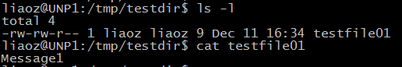

1. First run the server:.sudo ./ofs_server
2. Then run the client:./elec590_ofs

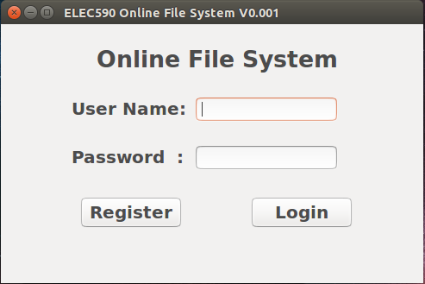

1. Click Register to register your account

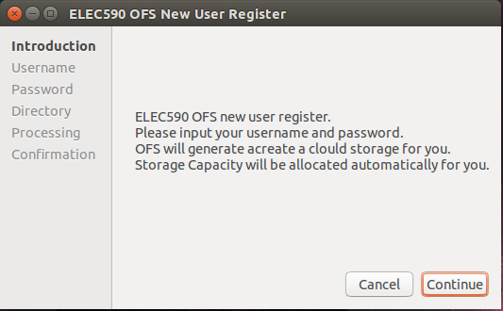

Click continue.

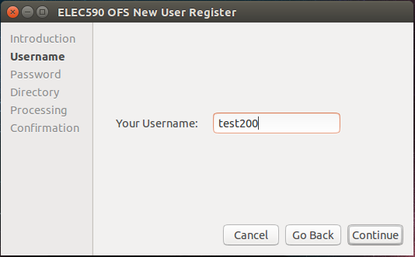

Input your username

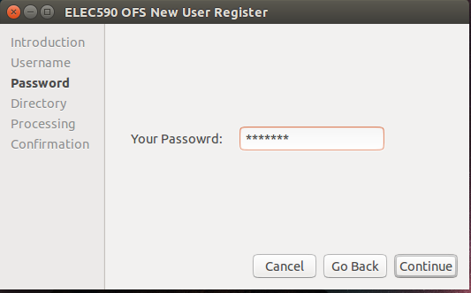

Input your password

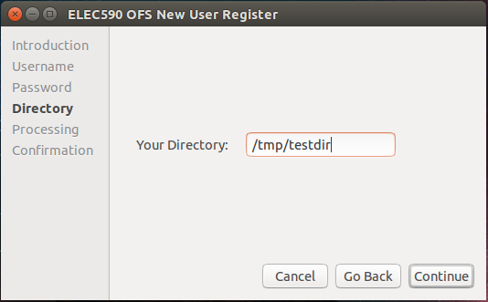

Input your client directory path

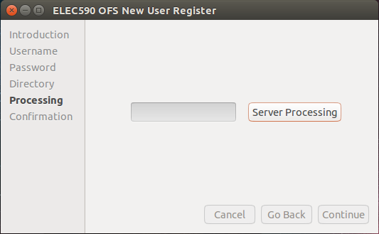

Click Server Processing to setup your account.

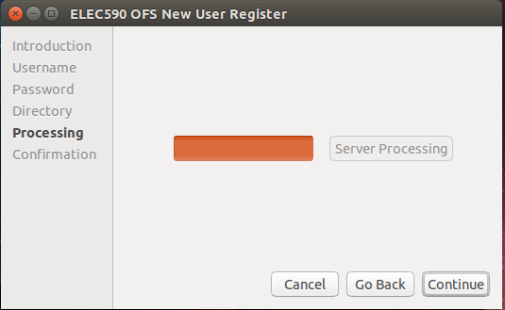

Click Continue.

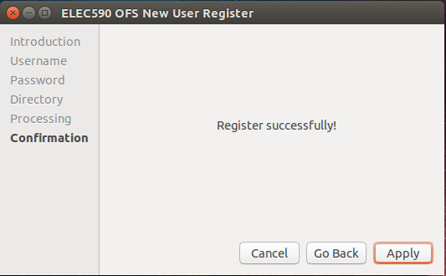

Click Apply.

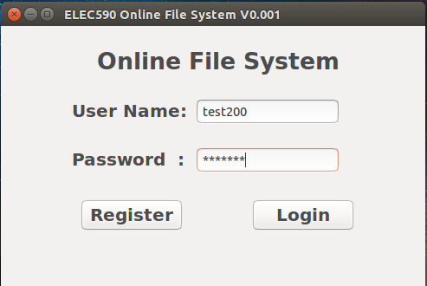

Login right now.

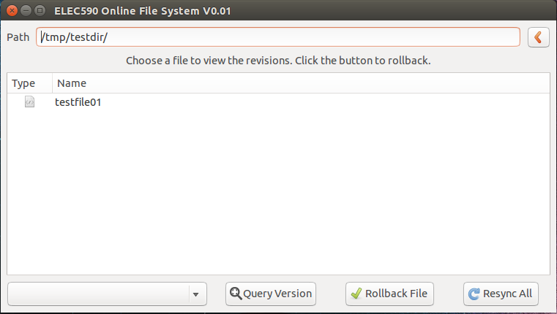

Click “Resync All” to sync all your files to the server.



Delete the testfile.

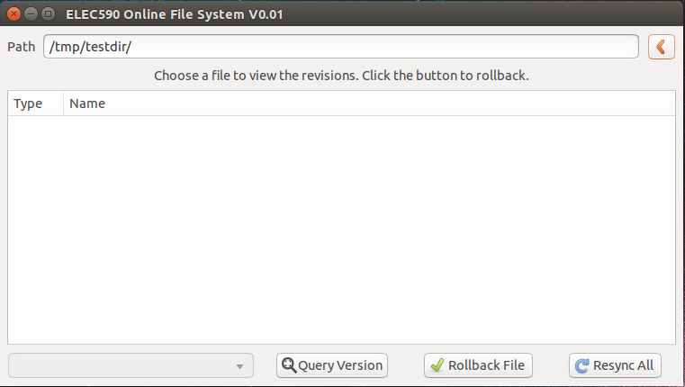

Click the fresh button. No files left.



Click “Resync All” again to restore your files and click the fresh button. File restored.



Do some modification to your files.(e.g. add another line) and click “Resync All”

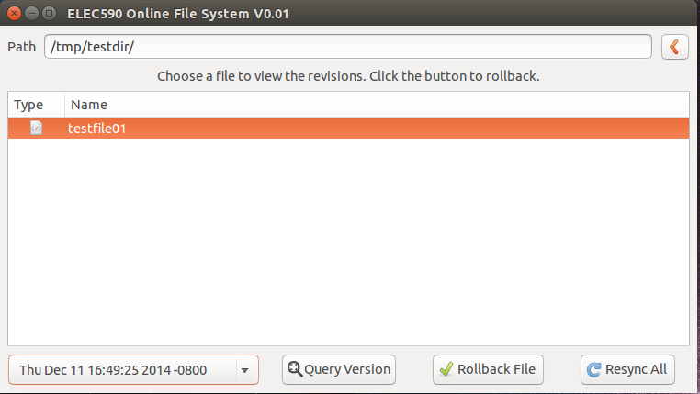

Select the file, and click the “Query Version” button, select a timestamp to restore your file. Click the “Rollback File” and “Resync All” button.



You get back your file.